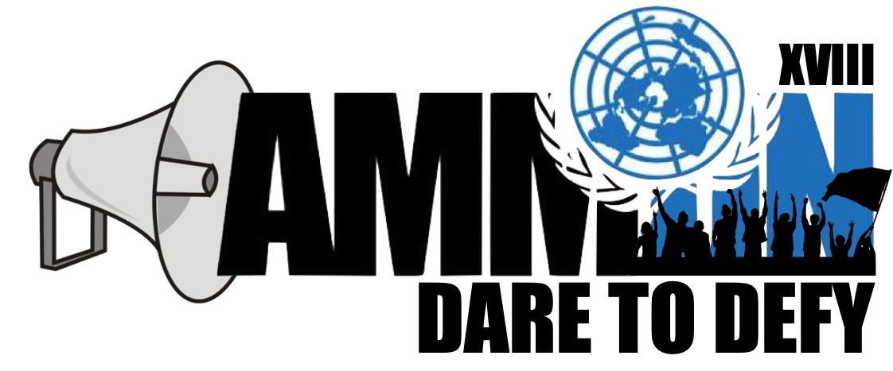

Forum: Sustainable Development Committee
Issue: Establishing frameworks sustaining water and energy in member states
Student Officer: Karim Nabulsi
Position: President of the Sustainable Development Committee

- Introduction

There is a current worldwide requirement for perfect and sustainable power and water sources. Non-renewable energy sources are non-inexhaustible and require limited assets, which are dwindling because of high cost and environmentally damaging retrieval techniques. So, the need for cheap and obtainable resources is greatly needed. Numerous individuals likely wonder that; if sustainable power source is so valuable, for what reason don't we devour a greater amount of it? The response to the inquiry is that a considerable lot of the sustainable power sources are increasingly costly and progressively hard to recover. In this way, in view of these restrictions, the utilization of non-renewable energy sources has developed to an over the top rate.

Water is at the center of feasible improvement and is basic for financial advancement, solid environments and for human survival itself. It is indispensable for lessening the worldwide weight of illness and improving the wellbeing, welfare and efficiency of populaces. It is key to the creation and safeguarding of a large group of advantages and administrations for individuals. Water is additionally at the core of adjustment to environmental change, filling in as the essential connection between the atmosphere framework, human culture and the earth. Water is a limited and crucial asset that is key to human prosperity. It is just sustainable if very much oversaw. Today, more than 1.7 billion individuals live in waterway bowls where consumption through use surpasses characteristic revive, a pattern that will see 66% of the total populace living in water-focused on nations by 2025. Water can represent a genuine test to maintainable advancement however oversaw productively and impartially, water can assume a key empowering job in fortifying the strength of social, monetary and natural frameworks in the light of fast and capricious changes.

- Definition of Key Terms

Sustainable development goals:

The Sustainable Development Goals are the blueprint to achieve a better and more sustainable future for all. They address the global challenges we face, including those related to poverty, inequality, climate, environmental degradation, prosperity, and peace and justice. The Goals interconnect and in order to leave no one behind, it ís important that we achieve each Goal and target by 2030.

LDC’s:

Least developed countries (LDCs) are low-income countries confronting severe structural impediments to sustainable development.

MDC’s:

MDC stands for a more developed country, in which there is a much higher standard of living and the economy is diverse and strong.

Eco-Labelling:

the practice of marking products with a distinctive label so that consumers know that their manufacture conforms to recognized environmental standards.

MEDC’s and LEDC’s:

LEDC’s (Less Economically Developed Country) sector includes countries with a lower GDP and a lower standard of living than MEDC (More Economically Developed Country) countries. Indicators used to classify countries as LEDC or MEDC include industrial development and education.

- General Overview – Background information

We divide our energy use among four economic sectors: residential, commercial, transportation, and industrial. Heating and cooling our homes, lighting office buildings, driving cars and moving freight, and manufacturing the products we rely on in our daily lives are all functions that require energy. If projections are correct, we’re going to keep needing more. In the United States alone, energy consumption is expected to rise 7.3% over the next two decades. Global consumption is expected to increase by 40% over the same time period.

There are numerous types of energy generators. Each type of energy source potentially affects the earth if not monitored. The probable dangers will originate from over-request and in an attempt to meet increased demand. Self-guideline and government and state guidelines help shield this from occurring.

As indicated by appraisals by the International Energy Agency, the world's oil and gas stores will decrease by 40-60% in the following twenty years. Despite the fact that there are as yet gigantic gas holds in the world's covering, extraction is turning into an outrageous specialized test. Our coal stores will keep on going on for quite a while, however the utilization of this energy source results in high CO2 outflows, making this fossil fuels one of the real supporters of the greenhouse effect. Earthy people contend that putting away CO2 in sinks is certifiably not a supportable arrangement, and ought to accordingly just be viewed as a transitory measure. Uranium holds are as yet ample. In any case, while this energy source does not prompt CO2 emissions, it is dubious due to the dangers presented by radiation and long-haul stockpiling of radioactive waste.

The Environmental Protection Association (EPA) says one regular issue with these sources of energy is in the transmission of energy. Wind ranches and geothermal plants are worked outside of populated territories and need to get control back to customers. This can mean the clearing of gigantic stretches of land to run electrical cables. A straight course for these electrical cables is progressively effective, which can mean the annihilation of vast territories of living space to clear a path for the development.

There are numerous valid justifications for utilizing sustainable power sources. They are cleaner and less dirtying than customary types of energy, for example, coal and gas. Also, "inexhaustible" signifies they have recharged assets, so you hypothetically have a vast supply. Notwithstanding, these assets can be blundered, as well, bringing about harm to nature.

However, it’s not only energy that is raising such foreign interest, but the need for sustainable water measures that need to be taken, as well. Water is the largest natural resource but only 3% of it is freshwater, of which just 1/3 is accessible for use in agriculture and cities. The rest is frozen in glaciers or hidden too deep underground.
Today, the main water source for over 2 billion people are aquifers – underground stores of freshwater. As income levels have risen globally, so has the demand for water-intensive goods such as manufactured, meat, and dairy products, stressing global freshwater resources.
Such increase in global freshwater consumption has led to the depletion of over half of the world’s largest aquifers and is a problem that will likely deteriorate as demand grows. At this pace, available freshwater reserves needed to ensure basic water, food, and energy security are predicted to drop by 40%.
As the world warms, climate change can threaten ecosystems and environments that protect vital water resources, limiting access to them even more. 2015 marks the end of a decade of action by the UN on promoting water and sanitation issue, a campaign which has seen an improvement in awareness of the threat that water sustainability poses both to sustainable development and political security.
Water sustainability is, therefore, at the core of SDC’s goals. Failure to address unsustainable use of water now will mean greater struggles in the future to achieve goals in a myriad of other areas.

Sandra Postel, director of the Global Water Policy Project and the National Geographic Society's freshwater fellow, said freshwater scarcity presents a growing problem to be addressed during the United Nations Conference on Sustainable Development (Rio+20) in Brazil from June 20 to 22. "It manifests itself in the depletion of groundwater, and the drying up of rivers and lakes upon which people depend for irrigation to grow their food," she said. "The intersection of water scarcity, food security, and a changing climate on top of it all raises a suite of water concerns that urgently need to be addressed."

Much progress is possible. In fact, due to the dedicated efforts of governments and NGOs since the 1992 Earth Summit, safe drinking water has been made available to some 1.7 billion people around the world, with projects ranging from modern piped plumbing to rainwater collection and storage.

But an estimated 880 million people still don't have regular access to clean water. "And we haven't made nearly as much progress on sanitation," Postel said. "Something like 2.7 billion people are without adequate sanitation, so that challenge still looms very large." Policymakers will struggle to lower both numbers even as the planet's population rises by an expected three billion over the next 50 to 75 years.

Protecting the environment for the coming generations begins with more effective water management today.

Goal 7: Ensure access to affordable, reliable, sustainable and modern energy for all
Targets:

- By 2030, ensure universal access to affordable, reliable and modern energy services
- By 2030, increase substantially the share of renewable energy in the global energy mix
- By 2030, double the global rate of improvement in energy efficiency
- By 2030, enhance international cooperation to facilitate access to clean energy research and technology, including renewable energy, energy efficiency and advanced and cleaner fossil-fuel technology, and promote investment in energy infrastructure and clean energy technology
- By 2030, expand infrastructure and upgrade technology for supplying modern and sustainable energy services for all in developing countries, in particular least developed countries, small island developing States, and land-locked developing countries, in accordance with their respective programs of support

Goal 6: Ensure availability and sustainable management of water and sanitation for all:
Targets:

- By 2030, achieve universal and equitable access to safe and affordable drinking water for all
- By 2030, achieve access to adequate and equitable sanitation and hygiene for all and end open defecation, paying special attention to the needs of women and girls and those in vulnerable situations
- By 2030, improve water quality by reducing pollution, eliminating dumping and minimizing release of hazardous chemicals and materials, halving the proportion of untreated wastewater and substantially increasing recycling and safe reuse globally
- By 2030, substantially increase water-use efficiency across all sectors and ensure sustainable withdrawals and supply of freshwater to address water scarcity and substantially reduce the number of people suffering from water scarcity
- By 2030, implement integrated water resources management at all levels, including through transboundary cooperation as appropriate
- By 2020, protect and restore water-related ecosystems, including mountains, forests, wetlands, rivers, aquifers and lakes
- By 2030, expand international cooperation and capacity-building support to developing countries in water- and sanitation-related activities and programs, including water harvesting, desalination, water efficiency, wastewater treatment, recycling and reuse technologies
- Support and strengthen the participation of local communities in improving water and sanitation management

- Major Parties Involved and Their Views

The global achievement of the goals is determined by the SDG Index and Dashboard, a scale from 0 to 100, where 0 is the worst level of implementation and 100 means full compliance with the targets. In this ranking, Sweden (84.5), Denmark (83.9), Norway (82.3) and Finland (81) top the leading positions, mainly due to their good performance in social and economic issues, although the data show that they must still work on the transition to a low carbon economy.

Spain ranks 30th with 72.2; Chile is 42nd with 67.2; Mexico is 56th with 63.4; Peru is 81st with 58.4 and Colombia is 91st (57.2). In addition, countries like the United States is in the 25th place with 72.7; Canada is 13th with 76.8; Australia is 20th with 74.5 and the United Kingdom is 10th with 78.1.

By contrast, African countries like the Central African Republic (26.1), Liberia (30.5), the Democratic Republic of the Congo (31.3) or Niger (31.4) are in the queue. They share lacks in all aspects, especially poverty, hunger, education, and peace and justice.

USA: Overall, Americans support protecting the environment, but there are deep partisan divides on the issue. In a Pew Research Center survey conducted last year, about three-quarters of U.S. adults (74%) said “the country should do whatever it takes to protect the environment,” compared with 26% who said “the country has gone too far in its efforts to protect the environment.”
South Africa: While close to 90% of South African households can access piped water on estimate, most of these households don’t have water running directly into their homes. Less than half (46.4%) of South African households are estimated to have water piped in their homes, 26.8% have access to water on their property while 13.3% need to share a communal tap.
China: China has more than a fifth of the world's population but only 7 percent of its fresh water. On top of that the North China Plain is home to about 42 percent of China's population but only has 8 percent of the country's water resources. If the region where a country its water availability would rank below Morocco. It is estimated that China will need to increase its water supply fivefold to meet its industrial needs by 2035.

- Timeline of Events

“On 1 January 2016, the 17 Sustainable Development Goals (SDGs) of the 2030 Agenda for Sustainable Development — adopted by world leaders in September 2015 at an historic UN Summit — officially came into force. Over the next fifteen years, with these new Goals that universally apply to all, countries will mobilize efforts to end all forms of poverty, fight inequalities and tackle climate change, while ensuring that no one is left behind.
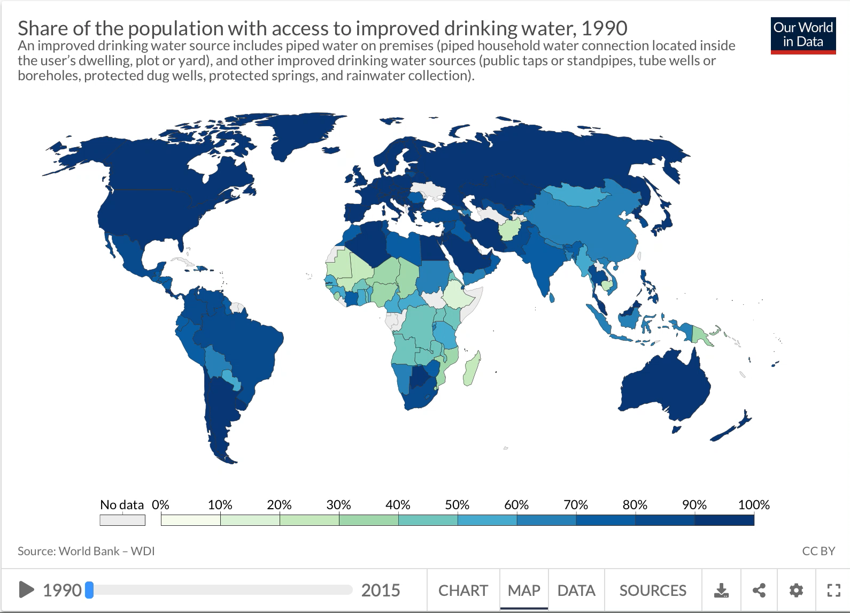
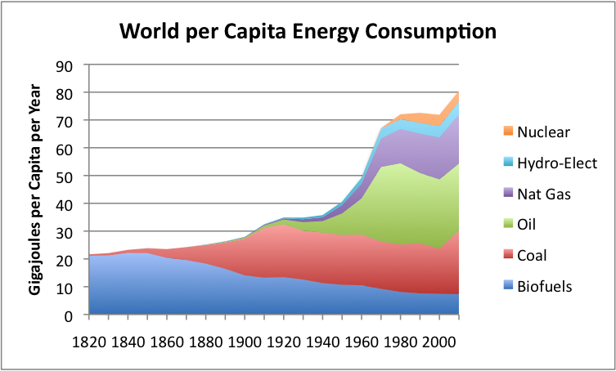
The SDGs build on the success of the Millennium Development Goals (MDGs) and aim to go further to end all forms of poverty. The new Goals are unique in that they call for action by all countries, poor, rich and middle-income to promote prosperity while protecting the planet. They recognize that ending poverty must go hand-in-hand with strategies that build economic growth and addresses a range of social needs including education, health, social protection, and job opportunities, while tackling climate change and environmental protection.”
- UN Involvement, Relevant Resolutions, Treaties and Events:

1980: The concept of sustainable development appeared for the first time in world conservation Strategy (WCS)
The WCS defines the four main factors in natural resource destruction:

• Poverty
• Population pressure
• Social inequalities
• International trade conditions

1988: Creation of the International Panel on Climate Change (IPCC)
It is responsible for the scientific processes of global warming.

2002: World Summit Sustainable Development in Johannesburg
Developing partnership with civil society (local communities, governments, citizens, associations, companies, etc.) assumed an important dimension.

2012: Rio+20 Summit – UN Conference on Sustainable Development (UNCSD)
2 themes: the green economy in the context of sustainable development and the institutional framework for sustainable development.
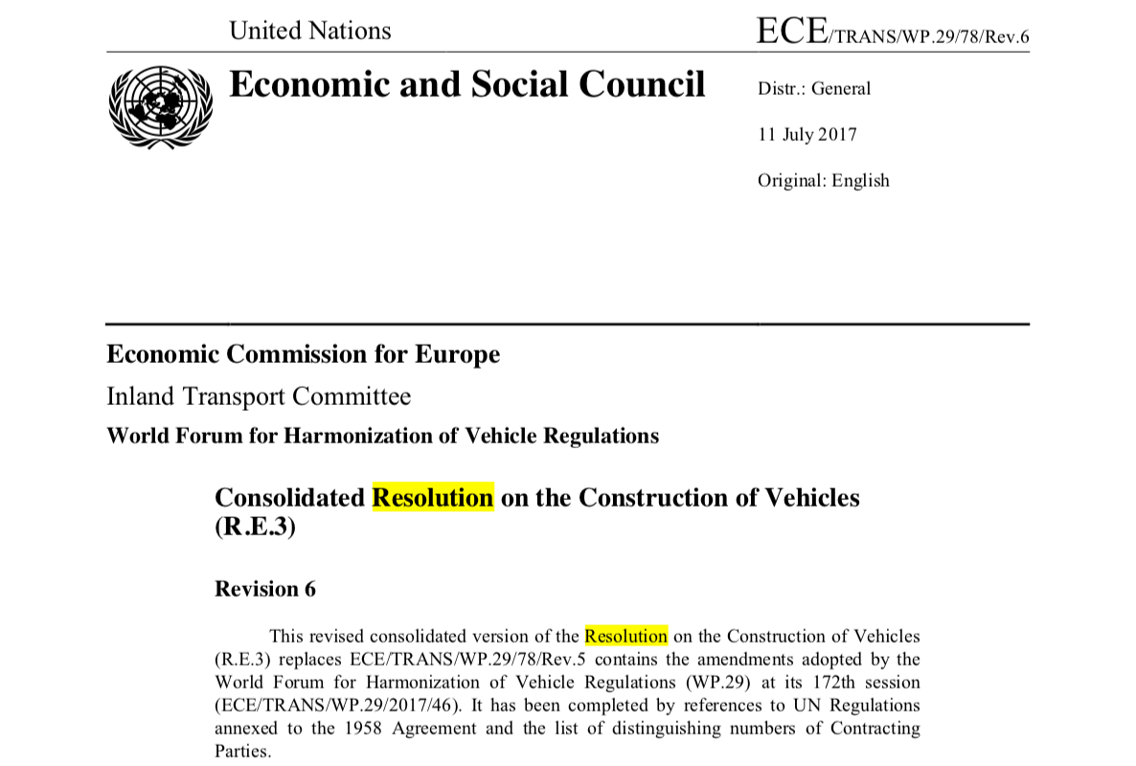
- Evaluation of Previous Attempts to Resolve the Issue

https://www.unece.org/fileadmin/DAM/trans/main/wp29/wp29resolutions/ECE-TRANS-WP.29-78r6e.pdf

Automated vehicles can possibly make more secure, increasingly proficient and naturally agreeable transport, which could reshape whole areas of the economy and improve the lives of a huge number of individuals, outstandingly those unfit to drive or with restricted access to portability. Be that as it may, numerous inquiries identifying with wellbeing norms, traffic rules, protection routines, cybersecurity and information insurance, to give some examples, should even now be tended to before the mass acquaintance of these vehicles with the market.

In view of this current, UNECE's Global Forum on Road Traffic Safety (WP.1), the main lasting intergovernmental body of the United Nations committed to street security, has received non-restricting lawful goals filling in as a guide for the nations which are Contracting Parties to the 1949 and 1968 Conventions on Road Traffic in connection to the sheltered arrangement of exceptionally and completely automated vehicles in street traffic.

The goals offer suggestions to guarantee the protected cooperation between computerized vehicles, different vehicles and all the more by and large all street clients, and stresses the key job of people, be they drivers, tenants or other street clients. While the Global Forum plans to revise the goals as innovation creates and as experience aggregates with respect to the utilization of very and completely computerized vehicles in street traffic, there have been pointing out for turning the legitimate substance of the 1949 and 1968 Conventions on Road Traffic.

In sum, this solution, although does benefit the environment and causes decreased carbon emissions released into the atmosphere, it does not solve the issue of energy sustainability (which is the main goal of the UNECE). The resolution has no mention of how the cars would be more efficient and consume less fuel per unit time, to make a certain quantity of energy; and therefore, this issue does not help energy become more sustainable for the future.

The need to provide adequate, sustainable, and environmentally sound supplies of energy to fuel global economic growth has created an imperative for greater international cooperation to increase efficiencies in energy production and use. Strategies that emphasize energy efficiency can offer not only economic advantages but also social and environmental co-benefits. Local, national, regional and global policies that promote investments in energy efficiency can make significant contributions to providing energy for sustainable development and avoiding dangerous interference in the climate system.
Many energy efficient technologies and processes are available in different economic sectors, including power generation, industries and manufacturing, construction and buildings, household electrical appliances, as well as in transportation systems. However, international information sharing on energy efficient technologies and on national policies to effectively promote their dissemination and application has remained comparatively limited.

- Possible Solutions
First solution:
China already is working with global energy companies to access its abundant natural gas resources. Shell and China’s national oil companies have several successful partnerships that are helping to achieve the government’s objectives. Shell has always been a company built on international relationships and technology. Today, mutually beneficial relationships with state-owned national oil companies are at the heart of the energy industry. They are driving progress and unlocking resources. At Shell, we are developing strong relationships with all of China’s national oil companies. Our ongoing cooperation with China is underpinned by four strategic priorities: First is developing China’s tight and shale gas resources to meet rising demand with cleaner fuels. According to the IEA, China has technically recoverable shale gas reserves of 25 trillion cubic meters. In 2009, Shell and PetroChina agreed to explore for shale gas in the Fushun block. We developed this relationship further last year when we signed a shale gas Production Sharing Contract for this project. It was a milestone for our partnership and the industry. Our second priority is helping Chinese enterprises grow overseas. One example is Gabon in West Africa, where Shell has two offshore exploration blocks. Last year, CNOOC acquired a 25% interest in these blocks, giving it an opportunity to work with us on a major exploration project outside China. Our third area of shared focus is international co-operation to import energy to China. In 2010, Shell and CNPC jointly bought Arrow Energy in Australia, a company that develops gas trapped in coal seams, then processes and sells it. While Arrow continues to supply gas and power in its domestic market, it is also working to turn coal-seam gas into liquefied natural gas which can be exported by ship to China and other international markets. Our fourth strategic priority is co-operation on research, development and technology.
For example, last year Shell signed two joint agreements with the research arm of CNPC for cooperative research on unconventional gas exploration and development, and enhanced oil recovery.
And in the next few months, we will launch a China Energy Study, a two-year project jointly carried out by Shell and the Development Research Centre of the State Council. The study will provide valuable insights into China’s energy developments. Shell also is proud to be one of the partners involved in the China Development Research Foundation’s energy and environment initiative. This initiative has proposed a series of policy recommendations to help China reach its long-term energy goals. In the years to come, we look forward to more close partnerships with China’s national oil companies. These partnerships show how business and government can collaborate to deliver a cleaner, more secure energy system.
partnerships will play a growing role in helping China make the most of its extensive resources, especially its natural gas, for the benefit of its people, its economy and its environment.
Second Solution:

With the conclusion and appraisal of the Millennium Development Goals in 2015, a new post-2015 development agenda will build on the lessons of the last 15 years. This new agenda will comprise 17 new Sustainable Development Goals (SDGs), representing an expansion and a more ambitious plan of action to help end poverty by 2030.
Goal 6 is a dedicated water goal – to “Ensure availability and sustainable management of water and sanitation for all”. The agenda will be adopted by Member States at the Sustainable Development Summit in September 2015.
The post-2015 development agenda may require a significant increase
in investment in infrastructure in a significant number of countries. Particularly there is a need for country- specific investment for water resources management and the control of water and wastewater quality, as well as for operation and maintenance necessary for the sustainability of services from both existing and new infrastructure, not forgetting funding of related governance functions.
Apart from the development of new infrastructures, important in- vestments will be required to upgrade and maintain the existing ones in or- der to avoid them becoming obsolete and insecure.
Countries will have to find the financial capacity to undertake all this by working on strategies to at- tract financing for water projects, making an early approach to potential funders and making appropriate provisions in their own budgets.
Innovations in environmentally sound technologies, which are not already in the market, are often more expensive than incumbent technologies, without the necessary supportive infrastructure. This lack of infra- structures makes easy for incumbents,
This includes those initiatives in- tended to ease or remove barriers that inhibit the adoption of water technologies everywhere –such as weak market demand, uncertain return on investment, and technological lock-in to current infrastructure– as well as other barriers that are more specific to some developing countries, such as lack of technical skills and capacity. Patents policies may need to consider facilitating the use of technology in developing countries. Competition, policies may be examined under the lenses of its potential to foster or inhibit the adoption and dissemination of new technologies.
Successful environmental technology adoption requires well-functioning public and private sector institutions, with good governance, efficient administration, an effective legal system, strong management skills and investment in R&D.
Lack of good governance can specifically hinder the opportunities of Small and Medium-sized Enterprises
–SMEs– to participate in the implementation of water related solution. The creation of enabling and flexible institutional setups is a clear pre-condition for technology development and innovation.
Institutional inertia often favors technology inertia: rules are shaped to routinely approve traditional and well-established technologies while
increasing the costs of adopting innovations that may not find an easy way through red tape.
High transaction costs for SMEs, in the position to use low scale and better adapted innovation, may play in favor of big firms facing less un- certain regulations and having better access to public authorities.
- Guiding Questions

- What’s the SDG index and dashboard of the member state that I represent?

- Is my country involved in any water or energy treaties and or organizations?

- Is my country a developing or developed country?

- Are there any agreements or organizations regarding water or energy sustainability in any of my neighboring countries?

- Is my country rich in fuels or resources that can generate energy?

- How much energy does my country consume per year?

- How much energy does my country generate per year?

- Are my county rich in natural water resources?

- How much water does my country consume per year?

- How much water does my country generate per year?

- Is my country allied with any countries that have good sustainable energy and water strategies?

- Is my country allied with any countries that have bad sustainable energy and water strategies?

- Who has my country allied with in the past or present, to make any agreements regarding sustainability?

- What strategies has my country implemented to become more energy and water sustainable?

- Is my country economically stable enough to implement any more strategies?

- Appendices and useful links

“Commission on Sustainable Development (CSD) .:. Sustainable Development Knowledge Platform.” United Nations, United Nations, sustainabledevelopment.un.org/intergovernmental/csd.
“Energy - United Nations Sustainable Development.” United Nations, United Nations, www.un.org/sustainabledevelopment/energy/.
“Energy.” UN, www.unece.org/energywelcome/quick-links/un-energy.html.
Manso, Ramos Pires, and Niaz. “Renewable Energy and Sustainable Development.” Estudios De Economía Aplicada, Asociación Internacional De Economía Aplicada, 1 Jan. 1970, www.redalyc.org/html/301/30126353001/.
“Resolutions.” UNECE, www.unece.org/trans/main/wp29/wp29wgs/wp29gen/wp29resolutions.html.
“Sustainable, Development, United Nations, Rio+20, Decade, Water for Life, 2015, UN-Water, United Nations, MDG, Water, Sanitation, Financing, Gender, IWRM, Human Right, Transboundary, Cities, Quality, Food Security.” United Nations, United Nations, www.un.org/waterforlifedecade/water_and_sustainable_development.shtml.
“UNECE Adopts Resolution on the Deployment of Highly and Fully Automated Vehicles in Road Traffic.” UNECE Adopts Resolution on the Deployment of Highly and Fully Automated Vehicles in Road Traffic, www.unece.org/info/media/presscurrent-press-h/transport/2018/unece-adopts-resolution-on-the-deployment-of-highly-and-fully-automated-vehicles-in-road-traffic/doc.html.

“UNECE Adopts Resolution on the Deployment of Highly and Fully Automated Vehicles in Road Traffic.” UNECE Adopts Resolution on the Deployment of Highly and Fully Automated Vehicles in Road Traffic, www.unece.org/info/media/presscurrent-press-h/transport/2018/unece-adopts-resolution-on-the-deployment-of-highly-and-fully-automated-vehicles-in-road-traffic/doc.html.
“United Nations Forum on Energy Efficiency and Energy Security for Sustainable Development: Taking Collaborative Action on Climate Change .:. Sustainable Development Knowledge Platform.” United Nations, United Nations, sustainabledevelopment.un.org/index.php?page=view&type=13&nr=359&menu=1634.
“Water Action Decade - United Nations Sustainable Development.” United Nations, United Nations, www.un.org/sustainabledevelopment/water-action-decade/.
World Future Council. “Renewable Energy and Sustainable Development.” World Future Council, World Future Council Https://Www.worldfuturecouncil.org/Wp-Content/Uploads/2017/03/Wfc-Anniversary-Logo-Website-Bigger-300x115.Png, 24 Oct. 2016, www.worldfuturecouncil.org/renewable-energy-sustainable-development/.

- Contact Info
Email: Karim_nabulsi@abs.edu.jo

