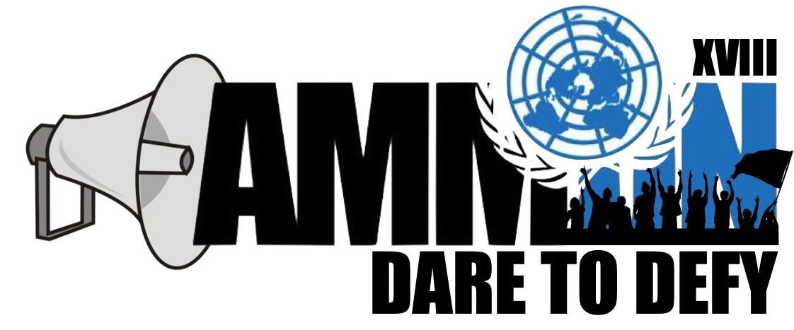

Forum: Advisory Panel
Issue: The Venezuelan Crisis (Economic)
Student Officer: Khaldoun Kiswani
Position: President

- Introduction

The economic crisis in Venezuela arose between 2012 and 2013, and across the years it has shown that it is not only an economic but also an institutional, political and social crisis. The road to the crisis started during the presidency of Hugo Chavez, and continued with the now President Nicolas Maduro, who keeps up the same policies of his predecessor. The crisis unfolded with the rising of different problems in the Bolivarian Republic of Venezuela, such as the increase of unemployment, the financial crisis and the lack of essential food, hygiene and health products. Shortages in Venezuela resulted from the economic mismanagement of the government. The UN and several other organizations have offered food aid to the country, but Venezuela refused; this exacerbated the Bolivarian diaspora (mass emigration of Venezuelans) and murder rates in the country raised significantly. The hunger in Venezuela, the lack of credits in banks, political corruption, lack of local productivity and the high dependence in oil export prices are the factors that contributed to the aggravation of the situation. Meanwhile, the concentration of power in the executive branch and the erosion of human and political rights have let the government intimidate, persecute and criminally prosecute opposition members. Even though international help has been offered, the Bolivarian Republic of Venezuela has refused it since the government doesn’t want the international community intervening in its managing of the country. Meanwhile, several American countries have signed the Lima Declaration (2017), which declares that Venezuela is no longer a democracy and condemns the violations of human rights in the country. The international community fears that the crisis will continue to get worse, living conditions will further fall, authoritarianism will deepen and the mass emigration will intensify. All of these problems affect both the internal security of Venezuela and also the surrounding Latin American region. Given that Venezuela has the largest oil reserves in the world, foreign powers are also closely following the situation. For the benefit of Venezuela and the whole international community, a solution to this crisis should be reached before it continues to deepen.

- Definition of Key Terms

P.D.V.S.A.

State-owned oil and natural gas extraction, refining and commercialization company. Founded in 1976 after the oil industry was nationalized. The company is in charge of exploiting the oil reserves in Venezuela, which are the largest in the world. PDVSA is crucial for the Venezuelan economy.

P.S.U.V. (United Socialist Party of Venezuela)

Socialist political party in Venezuela resulting from the fusion of the political parties which supported Hugo Chavez’s Bolivarian Revolution. It is a leftist party that follows Chavist ideas and holds him as a very important icon. Its current leader is Nicolás Maduro.

M.U.D (Democratic Unity Roundtable)

Electoral coalition of Venezuelan political parties formed in 2008 to oppose Hugo Chavez and the PSUV in general. Primarily formed of centrist, center-left and center-right parties.

Organization of American States (OAS)

International organization founded in 1948 and composed of the 35 independent states of the Americas, whose main aim is improving continental cooperation and integration in economic, political and other issues. The organization has the mission of defending democracy and Human Rights in the region.

UNASUR (Union of South American Nations)

Intergovernmental organization founded in 2008 originally comprised of 12 American countries. The organization was formed during a period where leftist governments controlled much of Latin America, and aimed at further integrating Latin American States. In 2018, six of its members suspended their participation for an indefinite period of time.

MERCOSUR (Common Market of the South)

Customs union founded in 1991 originally composed of Argentina, Brazil, Uruguay and Paraguay, allowing duty-free trade between the member countries and establishing a common external tariff on other nations. Venezuela joined in 2012, but was suspended four years later.

United Nations High Commissioner for Refugees (UNHCR)

United Nations body in charge of protecting the rights of refugees and displaced individuals and assisting their voluntary repatriation or resettlement in a new country.

Economic sanctions

The withdrawal of customary trade and financial relations with a specific country, often to force a certain political, economic or social change on the recipient.

Migrant

Person who moves from one place to another, usually looking for better living conditions and opportunities. The decision to migrate is taken freely by the individual, unlike in the case of a refugee, where factors like persecution and war force the person’s movement. However, migrants may decide to leave their homes as a result of economic problems. Depending on the case, migrants may or may not have legal authorization to enter or reside in a country. Often, the situation of migrants can be of vulnerability.

Bolivarian Diaspora

Migratory movement in the Americas stemming from the voluntary emigration of millions of Venezuelans from their country during the governments of Hugo Chavez and Nicolás Maduro. It is the largest recorded refugee crisis in the Americas. Around 2 million people have left the country since the massive emigration began.

Inflation

A sustained increase in the prices of goods and services over months or years, as measured by indexes like the Consumer Price Index. This leads to a decrease in the purchasing power of the currency of the country. High inflation rates have a very negative impact on the economy, harming disadvantaged individuals the most. An excessively high rate of inflation is described as hyperinflation.

Default

When a country is unwilling or unable to meet the obligations of a loan agreement, it declares it is in default, meaning that it will cease to pay off its national debt. This lowers trust in the country from investors, making it harder to borrow money in the future. A default may be ended by negotiating an arrangement with creditors.

Foreign aid

International transfer of capital, goods or services from a country or international organisation for the benefit of the recipient country and/or its population. Emergency humanitarian aid is provided when a country faces a humanitarian crisis, and it aims at alleviating the short-term impacts of such a situation. International organizations like the UN are often not only tasked with delivering money to a country, but also implementing programs to alleviate the crisis.

Lima group

Multilateral body established after the signing of the Lima Declaration formed by 17 American countries seeking a peaceful resolution to the crisis in Venezuela. The Group supports the National Assembly and considers that democracy in Venezuela no longer exists.

Chavismo

Political ideology established by Hugo Chavez that includes socialist ideas, left-wing populism, Bolivarian elements, patriotism and Latin American integration as its main components. Chavez implemented a “Bolivarian revolution” in Venezuela following the guidelines of this ideology.

- General Overview – Background information

A history of Wealth and Inequality

The history of Venezuela is marked by the discovery of oil, a crucial energetic resource for the world, and the way in which the profits from its exploitation are distributed amongst the society. In the middle of the XXth century, Venezuela is able to leave behind decades of dictatorships to become a democracy. The country is in a good position, since it has the largest reserves of oil in the world and can use the revenue from its exports to grow economically and develop. The fact that oil prices peak during the 1970s further contributes to this beneficial context for the country.

However, the nation faces certain internal difficulties. Democracy is limited, since only the two main parties participate in elections after a pact is made between them. Moreover, corruption within the government is endemic. Still, Venezuela’s economy is one of the richest of Latin America.

Problems start to arise when oil prices fall during the 1980s. Venezuela had failed to diversify its economy beyond oil, and the benefits of its exploitation had been concentrated on the hands of a few, creating large social inequality. The government’s attempts to implement austerity measures end up hurting the middle and lower classes the most. In this context, Hugo Chavez, a member of the Venezuelan army, starts to form a movement to try and get to power and change how Venezuela distributes its wealth. He is inspired by the Cuban Revolution and the Castro brothers, and he intends to implement leftist policies in Venezuela.

The Commander

Chavez first attempts to get to power through a coup in 1992, but he fails. Six years later, he is elected president. He runs on a leftist, socialist platform, with a marked populist tone, an anti-imperialist and anti-US rhetoric, and promises to end poverty and bring social justice to the forgotten lower classes.

Chavez’s first years in power begin to show his attitude towards government. He implements laws to redistribute wealth and benefit small farmers. He uses the revenues from oil exports to carry forward programs to alleviate poverty. At the same time, he nationalizes many crucial industries, most importantly the oil industry, which gives him a greater control over the economy. In spite of some failures, like his defeat in the 2007 referendum, Chavez is able to progressively accumulate power in the government and in his own hands. He starts restricting the free press, and installs a strong propaganda apparatus. In 2009, he succeeds in eliminating term limits for presidencies. Human Rights Watch accuses his government of having a poor record regarding human rights.

In the international stage, he realigns Venezuela away from the US and towards Russia, China and Cuba. His government becomes a model for other similar leftist leaders in the region.

Chavez’s policies exacerbate the divisions in Venezuelan society: many of those benefited by the ever-enlarging state apparatus support him and allow him to win four presidential elections, the last one in 2012. Others resent his restriction of economic freedoms and fear that he is accumulating too much power. By 2013, social divisions are growing, institutions are weaker and the international context promises problems as oil prices drop. In this scenario, Chavez dies of cancer. His successor, Nicolás Maduro, would have to face the crisis that had been building up over the last years.

The Explosion of a Crisis

Maduro’s government has to manage an economy which is largely based on oil in an international context of falling oil prices. Moreover, the country’s reserves are dwindling, and it accumulates debt. Maduro has to try to manage a government with a large fiscal deficit while maintaining the social policies that sustain his support. This combination ends up leading to incredibly high inflation (in the order of 10.000% a year) coupled with unemployment, economic recession and scarcity of basic goods. Maduro makes attempts at devaluations, price controls, austerity programs and even the launching of a cryptocurrency, but problems persist. The fact that the US imposes economic sanctions worsens the situation.

The ongoing economic crisis clearly has social and political repercussions. Although a loyal base keeps on supporting Maduro, more people start siding with the opposition, clearly angry at the economic failures of Maduro’s government. This is how protest movements arise and the opposition manages to win legislative elections. Maduro shows that he is not willing to give up power by bypassing the National Assembly, controlled by the opposition, with a newly formed constitutional assembly. The institutional deterioration in Venezuela leads many Latin American countries to declare that democracy is effectively inexistent in the country. Moreover, the fact that there are no institutional channels to debate resolutions to the crisis worsens tensions and creates an obstacle to any agreement.

In the meantime, civilians suffer shortages, inflation, rising insecurity and crime, and overall hopelessness. Many choose to seek a better future in Spain, Miami or other Latin American countries, generating a large migratory movement, where some migrants are able to travel further than others, which end up in the frontiers with Colombia and Brazil. The political, social and economic crisis combine to generate a humanitarian and refugee crisis, where Maduro’s government refuses foreign aid and the country continues to submerge in chaos.

Unified Power

Since former President Chávez and his supporters in the National Assembly held a political takeover in 2004 of the Supreme Court of Justice, the judiciary has ceased to act as an independent branch of government. Members of the Supreme Court have openly rejected the principle of separation of powers and have publicly expressed their commitment to promote the government's political agenda. Therefore, the Venezuelan Executive branch has somehow taken control of the Judicial and Legislative branches, thus ignoring its own constitution, and at the same time concentrating the power in only one branch. This is one of the reasons why Venezuela is not considered a democracy anymore by many countries.

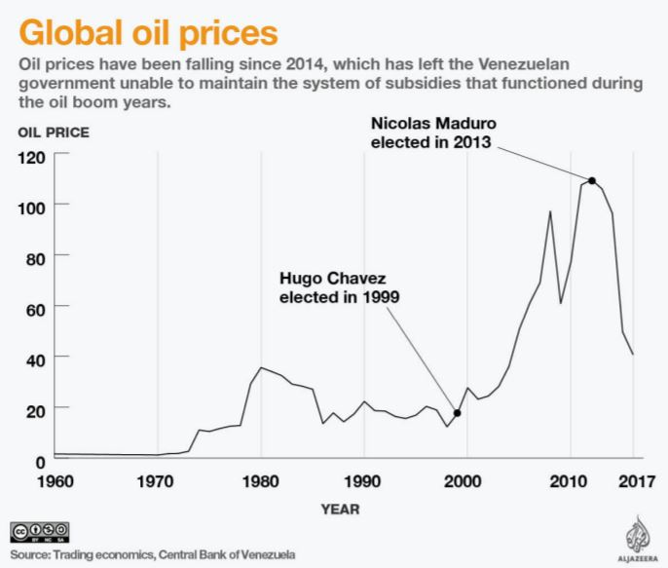
Economic Decline

The Venezuelan economic crisis stems from a number of factors. These include systemic corruption, lack of diversification of the economy beyond oil, fiscal deficit, mismanagement of nationalized oil companies, failed attempts by the government to control prices and excessive government spending.

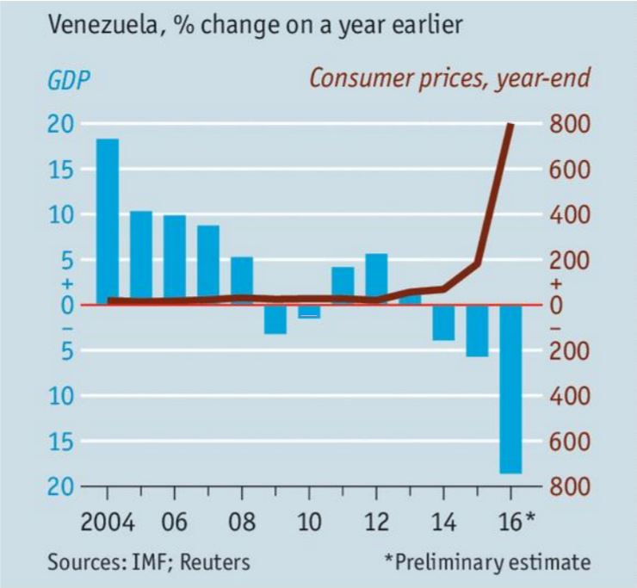
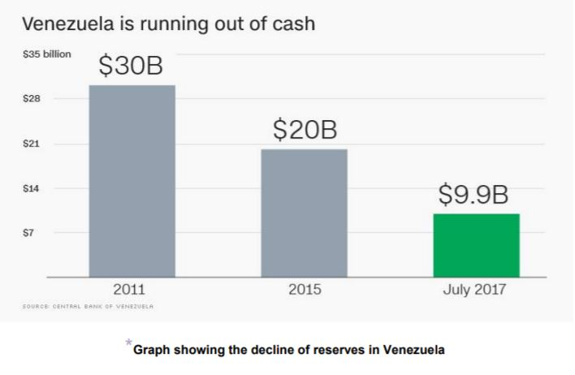
The situation is manageable so far as oil prices remain high and provide the country with large export revenues (oil accounts for 95% of the country’s exports). When oil prices fall, the deficit grows and the Bolivar (Venezuela’s currency) starts losing value, leading to high inflation. Venezuela begins accumulating debt and losing reserves. Its economy shrinks. Government attempts to control prices fail and scarcity of basic goods, including food and medicine, become the norm.

In addition, the government’s hostility towards foreign business and Chavez’s nationalizations have caused big companies to leave the country partially or entirely. This also increases the unemployment in the country.

Inflation keeps getting worse, and prices are expected to rise over 10000% next year. Maduro blames Venezuela’s unfavorable economic situation on his opponents, such as the United States, and their alleged attempts to stop Venezuela’s revolution.

- Major Parties Involved and Their Views

The Government of Maduro

A main aim of the Chavist government in Venezuela is to maintain its position of power. In spite of the chaos in the country, Maduro still holds an approval rating of around 30%. Over the years, the government has accumulated power in the figure of the president, enabling him to use force to achieve this aim. The government continues to blame the country's problems in the actions of foreign powers (particularly the US) as well as the internal elites that allegedly attempt to bring down the Bolivarian Revolution. The government has demonstrated that it is willing to use force to repress opposition protests. In spite of the economic problems, support from China and Russia coupled with this strong grip on the population help Maduro retain power. The fact that the country has not accepted aid could be seen as an indication that the government refuses to acknowledge the country’s problems, which can also be observed in Maduro’s rhetoric. In many aspects, it is beneficial for the government to maintain the status quo, which makes change much more difficult.

The Venezuelan Opposition

The opposition movement has had more failures than successes during the Chavist rule. In 2008, opposition parties unified their forces in the MUD coalition, realising that they would not be able to stop Chavez separately. Opposition leaders like Leopoldo Lopez have been jailed, and their protests repressed. Still, in 2015 the MUD was able to defeat Maduro’s PSUV in the legislative elections, which gave the opposition new hopes of change. This hope quickly faded, as Maduro manoeuvred to bypass the opposition controlled National Assembly. Today, after divisions on issues like whether to participate in regional elections or not, the opposition is internally fractured. This benefits Maduro, since there is no single force that clearly represents those against him. The main demands of the opposition are to have free and fair elections, to end the political imprisonments and repression and to restore the reign of law and human rights. However, because the coalition is only formed against Maduro and not around any common policies or ideologies, it is very weakly held together.

The United States

When Chavez got to power, he criticized the US heavily, considering it an imperialist power that posed a threat to his socialist model. Tensions between the countries rose, Chavez accused the US of fomenting a coup attempt in 2002, and Venezuela was included in Bush’s “axis of evil” for a period of time. After the reports of human rights abuses and the breach of democracy in Venezuela, the US imposed economic sanctions on high-ranking officials in 2014. With Trump’s arrival to the US presidency, relations have further strained. Trump intensified the economic sanctions on the country. He has also suggested the possibility of using military force to intervene in Venezuela, which in a sense legitimized Maduro’s rhetoric against him and was responded to with global rejection. The US has asked the OAS to suspend Venezuela from the organism. The US imports hundreds of thousands of barrels of oil per day from Venezuela, although imports have been decreasing for some time. Thus, it has an interesting in maintaining Venezuela as a source for this energetic resource. Both ideologically and strategically, Maduro’s government is a nuisance for the US.

Russia

After distancing itself from the US, Venezuela was led by Chavez towards a closer alliance with Russia. The countries have strong military ties: Venezuela is the second largest importer of Russian weapons in the world. Also, they have carried forward joint military exercises in the past. When facing economic problems, Venezuela has received loans from the Russian government. These loans are often repaid through oil shipments from Venezuela to Russian oil companies, which account to as much as 13% of the country’s total exports. Ties are also ideological: Chavistas would like to see an end to US hegemony in the world, and supporting Russia is, in Maduro’s words, “part of an effort to build a multipolar world”. For Russia, it is convenient to have a strong and dependent ally in the Americas region. Venezuela is close to the south of the US, and, as tensions between Russia and the US increase, Putin benefits from a loyal regional ally. Since the Venezuelan opposition has declared that links with Russia would be reduced if it got to power, Putin has a very big incentive to protect Maduro’s government politically, economically, militarily and diplomatically.

China

In a similar way to Russia, China provides significant support for the Maduro regime. The two countries have close economic ties, having undertaken joint economic programs in the energy, industry and transport sectors. China imports large amounts of oil from Venezuela, making the South American country an important strategic ally. Military ties are not as strong as with Russia. As the economic crisis worsened in Venezuela, China provided favorable repayment plans for the many loans that it had previously provided to the country. However, it refused to lend more money. Still, Venezuela is important for China in a regional sense, since the alliance allows China to increase its influence in the Latin American region. Thus, China is keen on protecting Maduro’s government in the international stage.

Lima Group

This group of 17 American countries aim at finding a peaceful solution to the Venezuelan crisis. At the beginning of the last decade, Venezuela was the leader of the growing amount of leftist governments in Latin America; now, the trend has reversed and Venezuela is increasingly isolated in the region. The group criticizes the violations of political rights, human rights and democracy, supports the National Assembly and is in favor of excluding Venezuela from regional organizations. They also call for free and fair elections Amongst the members of the group there are countries with particular interests on the crisis. Colombia and Brazil have to deal with the growing influx of migrants through their borders, which causes complications, so they are very keen in finding a solution to the crisis as soon as possible. The members of MERCOSUR have decided to suspend Venezuela from their organization. Everyone in the group considers it potentially problematic for the region to have such an unstable country continue to worsen its situation. The Lima Group is significant because it represents the intentions and positions of those Latin American countries not aligned with the Bolivarian axis. So far, however, its attempts to achieve a change in the crisis in Venezuela have had little impact.

ALBA (Bolivarian Alliance for the Peoples of our Americas)

ALBA is a regional organization composed of Venezuela, Cuba, Bolivia and other left leaning governments of the Americas which aim at improving social, economic and political integration between its members. The countries in this alliance are closely aligned to Chavist and socialist ideologies, in contrast to the members of the Lima Group. Countries in ALBA support Maduro’s government, and ask that foreign powers refrain from intervening in its internal problems. They support Venezuela in regional forums like the OAS, trying to avoid sanctions or suspensions against Venezuela.

- Timeline of Events

Timeline of important events/Documents

1821: Venezuela gains independence from Spain, as part of a broader “Gran Columbia” led by Simon Bolivar.
1830: Venezuela separates from Gran Colombia, becoming an independent state. Rest of 19th century: The country sways between military dictatorships and civil wars.
1908-1935: Dictator Juan Vicente Gomez exploits the recently discovered oil reserves in the country to turn Venezuela into a main oil exporter at a global scale.
1958: Romulo Betancourt, a leftist candidate, is elected president after dictator Jimenez is forced to step down.
1964: First democratic transfer of power from one civilian to another takes place.
1973: Oil prices skyrocket as a consequence of armed conflict in the Middle East; Venezuela benefits from the high prices, which contribute to economic growth and stability. This situation allows the government to nationalize oil and steel industries.
1983: Oil prices drop, forcing the government to cut welfare spending.
1989: President Carlos A. Perez is elected; Venezuela seeks IMF loans and launches austerity programs to end economic depression. This leads to a general strike and riots that leave hundreds dead.
1992: Colonel Hugo Chavez attempts to reach power through two coup attempts, which eventually fail. Chavez is jailed for 2 years.
1998: Hugo Chavez is elected president. His party runs on a leftist platform that promises to end corruption and poverty and opposes US foreign policy.
2002: The armed forces attempt a coup after conflicts in the State owned oil company PDVSA arise. The coup fails.
2004: Chavez wins referendum to finish the remaining 2 years of his term as president.
2005: Chavez passes laws that aim at distributing land and limiting the ability of the press to criticise public figures. 2006: Chavez wins a third presidential term with 63% of the votes.
2007: Chavez nationalises key energy and telecommunications companies, which causes protests in favour and against the move.
2007: Chavez loses referendum to increase government power to control the economy and expropriate property.
2008: Venezuela strengthens relations with China and Russia through different military and economic deals.
2010: The opposition gains strength after parliamentary elections, but Chavez’s party retains a majority.
2011: Government extends price controls on basic goods to try to control inflation.
2012: Venezuela becomes full member of the Mercosur regional trading block. Chavez wins fourth term in office against opposition leader E. Capriles, in a close election.
2013: April: Chavez dies of cancer. Nicolás Maduro, his chosen successor, is narrowly elected president. November: National Assembly gives Maduro emergency powers to try to tackle the rampant inflation of more than 50% a year. December: Ruling Socialist Party wins local elections in spite of economic crisis.
2014: February - March: Opposition protests are violently broken up by the government, which accuses them of trying to launch a coup. Opposition leader Leopoldo López is jailed. November: as oil prices keep falling and the economic crisis worsens, the government announces cuts in public spending.
2015: An opposition coalition named “Democratic Unity Roundtable” wins two-thirds majority after parliamentary elections. This ends years of Chavist control of the National Assembly.
2016: January: Under pressure, three deputies from the opposition coalition resign from National Assembly, depriving the coalition of the two-thirds majority that would have enabled it to block Maduro’s legislation. February: Maduro announces devaluation and petrol price rise to fight economic crisis. September: Hundreds of thousands of protesters take to the streets in Caracas calling for Maduro’s removal. December: Venezuela is suspended from Mercosur by its other members.
2017: March: Pro-Maduro Supreme Tribunal of Justice dissolves the National Assembly. Protests begin. April-June: Maduro announces that a Constitutional Assembly will be formed to replace the opposition-controlled National Assembly. This, coupled with the arrest of opposition leaders, increases the magnitude of the protests against Maduro asking for early presidential elections. More than 100 people die and thousands are arrested as the protests are violently confronted by the government. July: Opposition holds unofficial referendum where seven million people reject Maduro’s plans for the new constitutional assembly. Still, elections for the assembly take place. The opposition boycotts the elections, and Maduro supporters end up making up most of the assembly. August: Chief prosecutor Luisa Ortega, who was investigating corruption charges and human rights violations, is forced into exile. October: Maduro’s party wins in 18 out of the 23 districts in regional elections against the opposition, strengthening its power. The elections are questioned by NGOs, the opposition and members of the international community after several irregularities are reported. December: Municipal elections take place, and the Chavists emerge victorious. Many opposition parties decide to boycott the elections, and irregularities are again reported. Boycotting parties are banned by the government from the upcoming presidential elections. The opposition is now weaker and internally divided. 2018: In face of the internal division in the opposition, Maduro decides to hold the presidential elections in May, earlier than previously established. Claiming that there will be electoral irregularities, the opposition decides to boycott the elections and asks the international community not to recognize them.

- UN Involvement, Relevant Resolutions, Treaties and Events:

The Security Council has not issued resolutions regarding the crisis in Venezuela. In November 2017, Russia, China and other members boycotted a Security Council meeting on the issue. However, other UN bodies have gotten involved in different ways.
The UN’s High Commissioner for Human Rights has found that, during the protest movements of 2017, the government was responsible for many grave human rights violations, including arbitrary detention and torture.
The United Nations have offered humanitarian aid to Venezuela. But this has been turned down by Maduro, who claims to be afraid of the international community interfering in the country.
In November 2016, the Human Right Council’s Working Group reviewed Venezuela and issued a list of 274 recommendations, ranging from poverty and health to political rights issues. Venezuela responded by arguing that it was already implementing many of the proposed solutions, and stated that foreign powers had been trying to undermine its progress regarding human rights.
In the 36th Session of the Human Rights Council at the United Nations in Geneva, Switzerland September 11, 2017, the topic of the humanitarian crisis in Venezuela was addressed. Here the “Lima 12” (11 Latin American countries and Canada) condemned the breakdown of democratic order and the violation of human rights in Venezuela, and expressed their concern about the government’s refusal to accept international humanitarian aid.
In the Human Rights Council thirty-seventh session, a resolution was adopted which condemned the economic sanctions against Venezuela by the United States, Canada, the European Union and their allies. It urged these countries to stop sanctioning other states since "such measures prevent the full realization of economic and social development of nations."
In March 2018, the United Nations High Commissioner for Refugees published a protection guidance to orient those nations receiving Venezuelan migrants. In the document, the body established that the migrants’ basic rights should be respected, and that migrants should be given possibilities to legally stay in the territories they arrive to without fear of being forced to return to Venezuela. The organization offered its technical knowledge to assist those countries receiving migrants.

- Possible Solutions

When considering how to solve this issue form an international standpoint, it is important to understand that multiple problems exist at the same time: solutions are needed for the political, economic, humanitarian and refugee crisis, which are interrelated yet have distinct aspects. At the same time, the international community should always prioritize peaceful solutions and try to directly interfere with local politics as little as possible. For Venezuela to start solving its problems, a return to a full democracy without restricted political rights is necessary. To start rebuilding the country’s institutions, open and free elections should be held. Given the mistrust from opposition parties towards the government as a result of previous instances of election irregularities, the international community has a very important role to play here. Elections could be controlled by international supervisors to ensure their transparency and provide legitimacy to their results. In this way, a new political start for the country could take place. However, it is likely that Maduro would not accept these supervised elections so easily. One possible course of action involves further applying economic sanctions to the government of Maduro, to punish him for human rights violations and breach of democracy, but most importantly to force a change. The idea behind this proposal is that sanctions would weaken Maduro’s ability to maintain his regime and the loyalties that keep him in power. Thus, he would have to negotiate a solution, ideally democratic, to the political crisis. Sanctioning countries should demand the release of political prisoners, the return of press freedom and the end of political persecution, together with the end of human right abuses. An attempt to block trade would have to include Venezuela’s Latin American neighbours, as well as global powers from the US to Russia, including the EU. When applying sanctions, the international community should ensure that these hit the government officials and not the Venezuelan people: the sanctions could deepen the crisis, worsen shortages, and make the refugee crisis even worse. The international community could also hope that internal change will be generated. Protest movements have appeared in the past demanding Maduro’s removal, and dissatisfaction with the government is widespread. Popular protests may intensify up to the point where it is impossible for Maduro to continue to hold on to power. The international community could then supervise the return to a full democracy. However, the way in which Maduro has repressed past movement protests indicates that such an alternative would be hard to turn into reality. It is important to find a way to get Venezuela to accept foreign aid. International humanitarian aid would be very important to alleviate the scarcity of food and medicine in the short term, so trying to get the country to accept it is very important. A possible reason for the rejection is that Maduro does not want to project an image of crisis and weakness, and that he is trying to hide the crisis. The international community could try to frame the aid in such a way that Maduro would be willing to accept it, for example, by channeling it through some of Venezuela’s allies. Regarding the refugee crisis of Venezuelan citizens in Brazil, Colombia and the Caribbean, the international community can also help. Organizations like the U.N. High Commissioner for Refugees could intensify efforts to organize the refugee camps until the situation is stable enough for people to return or find a new home. The UN should ensure that these vulnerable individuals are not subject to exploitation or risks while travelling. Countries receiving Venezuelan refugees should be offered help to enable them to cope with the growing influx of people. In the long term, Venezuela has a lot to do. The country needs to rebuild its institutions, political system and division of powers. Corruption and crime also demand structural changes. Economically, the country should diversify its economy so as to end its dependency on oil. Venezuela's recovery could be supervised once the short-term crisis ends, to avoid having the country fall in the same mistakes of the past.

- Guiding Questions

- What is your countries stance and relation to the Venezuelan Crisis?
- Has your country ever traded/ allied with Venezuela?
- How can your country aid in the humanitarian crisis in Venezuela?
- What countries are aiding with the humanitarian crisis in Venezuela? How is your country linked and related to those countries?
- What has the UN done in attempting to solve this issue?
- How were economic crises solved through history? Observe a pattern and notice the different methods executed to solve various humanitarian crises in the past.
- Is your country affiliated or allied with any NGO’s or country’s that are willing to aid in this crisis?
- How are the economic conditions in your own country? Is your country facing an economic crisis?

- Appendices and useful links

Venezuela Country Profile (CIA World Fact-book) - https://www.cia.gov/library/Publications/the-world-factbook/geos/ve.html

Venezuela profile - Timeline (BBC) –

http://www.bbc.com/news/world-latin-america19652436

Timeline: Venezuela’s tumultuous history (Al Jazeera) - https://www.aljazeera.com/indepth/features/2012/09/201292121430533264.html

Gobierno de Hugo Chavez (La Nación)-

https://www.lanacion.com.ar/2083058- pdvsa-la-joya-de-la-corona-chavista-que-ahora-languidece

International migration (UNESCO)-

http://www.unesco.org/new/en/social-and-humansciences/themes/international-migration/glossary/migrant/

Inflation (Business dictionary)- http://www.businessdictionary.com/definition/inflation.html

What is a Humanitarian emergency (Humanitarian Coalition)- http://humanitariancoalition.ca/what-is-a-humanitarian-emergency

Foreign aid (Britannica)-

https://www.britannica.com/topic/foreign-aid

4 Types of Constitutional Crisis (FiveThirtyEight)- https://fivethirtyeight.com/features/constitutional-crisis/

Human Rights violations and mass protests in Venezuela (OHCHR)- http://www.ohchr.org/EN/NewsEvents/Pages/DisplayNews.aspx?NewsID=21948&La ngID=E

UN Human Rights Council confronts Venezuela (Human Rights Watch)-

https://www.hrw.org/news/2017/10/02/un-human-rights-council-confronts-venezuela

Venezuela Country Profile (CIA World Fact-book) - Venezuela Country Profile (CIA World Fact-book) -

- Contact Info

Email: khaldoun_alkiswani@abs.edu.jo (President)

Email: ahmad_asfour@abs.edu.jo (Deputy President)

Email: jad_layyous@abs.edu.jo (Chair)

